In the autumn of 1919 my grandmother, Grace Clark, 21, a war bride, made the journey with her husband, Hugh, 24, a returning Canadian soldier, to her new home in Canada. The ship set sail from Liverpool, England on 17 September and arrived at the Port of Quebec on 25 September 1919.

The following is a true copy of the original letter she wrote (or as
she describes it - her "epistle") to her family back in Sheffield, England of her trip on board the ship - "Melita". The letter was more like a journal of her trip. It was written in pencil on both sides of 5 x 8-inch paper, more than 68 pages in all. Although some of the pages are missing or tattered, the majority of the letter is still intact and is very interesting to read.
Grace Gibson was born prematurely on 05 May 1898 at Clydebank, Scotland to Francis Oliver Gibson and Jane McCalman. She was the eldest child of four. Shortly after her birth the family moved to Belfast, Northern Ireland where they lived for Grace’s early years. Her family moved to Sheffield, England circa 1911. This is where Grace met Hugh when he was stationed nearby during World War One.

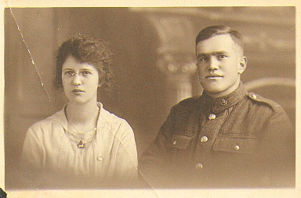

Figure 1.1 – A photo of the author Grace (Gibson) and her husband Hugh Clark taken at 4196 A. Seaman & Sons 115 Pinstone Street Sheffield, England, shortly before they left for Canada in 1919.

[Thursday — September 18, 1919]
…. night, and felt quite rested this morning. Last night our watches had to be put back an hour, as there is no “daylight savings” recognised after we leave English shores.
Some were up very early this morning, at four & five o’clock, I was up a six and had to “queue” for first sitting “breakfast”. — We are able to have all meals together which makes it so much more pleasant.
At present I am sitting on the upper deck and the waves are continually spraying us with “showers of blessing.”
The sea is awfully rough and has been for some hours. — Quite a large number of people have been sick already, but I am pleased to say I feel o.k. I eat a hearty breakfast consisting of bacon & liver. Of course that does not say I shall not be sick but I am hoping not.
The sun is shining gloriously, although the wind is very sharp & piercing, thanks to my nice warm coat mother, dear, I don’t feel cold.
Hugh is sitting beside me reading one of the books you bought him.
There is no doubt about it, the “Melita” is a very fine boat, and “runs” along fairly smoothly.
We sailed round by the north of Ireland, and this morning we could just see the coast away in the distance.
The young man who was so chatty yesterday was singing in the dining hall last night, and has a very good tenor voice.
We are not spending much time below, as one feels so much better up on deck, in the fresh air. —
It’s a wonderful sight, gazing on such a wide expanse of water, and to see other ships in sight.
The boat is fairly smoothly going at present.

Friday Morning 7:40 [September 19, 1919]
Here I am again, and feeling in the pink, after yesterday’s very stormy sailing. — We had a terrible day of it yesterday, while passing over what is commonly called the “Devil’s Hole.” — Some of the sailors were sick, and had Hugh & I not lain down all afternoon, and evening, we would have been among the number.
The “Devil’s Hole”, is about one day’s sailing, and is where four or five different waters meet, which consequently causes a very big ground swell.
We both said good night at about 9 o’clock, and had a splendid night. I was up at a quarter past six, and was already dressed, and washed when Hugh made his appearance.
At seven o’clock, we proceeded to the breakfast table, and made a good show. Now we are sitting on a rug on the upper deck floor, and covered over with another. The waves keep giving us a shower bath, which is making his letter rather blotchey.
My pencil yesterday was not copying ink, and consequently the first part of it may be rather indistinct. I hope however you will not have any difficulty in reading it. —
Now a little about the people on board. …There are heaps of young children and babies, and the poor mothers are having a trying time of it, trying to nurse, when they should be lying down. However from what I see the Canadian soldiers are very attentive to their sick wives, & do their share of nursing.
Hugh is out of this act, which is perhaps unfortunate I as it would have been an excellent experience for him. — Never the less we are delighted it is not the case, for believe me it is hard enough looking after oneself, never mind children. So Mother, leave all your babies behind when you cross the “Herring pond” to Canada, or else pack them safely away in your trunks.
Talk about being “Rocked in the cradle of the deep” it is such with a vengeance.
Today the weather is dull, and very windy, but much calmer than yesterday and the sailors say we should be out of the worst part, by night.
The boat is making good headway, we have run 272 miles up to last night, and we are going faster today. (ship is capable of doing 17K an hour)
At Liverpool docks I remarked to Hugh, that the sea was not very blue, and wondered where the poets were looking when they talked about the “ocean blue” — but now, you should just see the sea, it is beautifully blue, speckled with white dashing foam.
Up to now we have seen no other boat, and we seem to have the whole “floor” to ourselves. I have seen nothing of a mail bag on board, and I don’t suppose this will get posted until we reach Quebec. Hugh says that he thinks by the time we get there, he will have to see about sending this by parcel post. I may have to post it in two sections.
My “wee Hughie Hugg” says I am a good sailor, for there are very few men & women who have not had a bad time of it.
Oh! Cissie your scarf has proved a fine comfort on the boat, and keeps me fine & warm. I have my sweater on underneath my big coat, and feel as warm as if I was sat beside the fire, at 217 Chesterfield Road.
Hugh thinks my “paddy hat” the finest he has seen, and keeps sending admiring glances in my direction — “Thank you Thank.” —
We have some fine musical concerts below deck, among the “baby passengers” and I can assure you there is some fine talent among them. Their lungs are very powerful, and the sound carries a long way, especially at night time, when we “single uns” don’t appreciate it —?
Now for yourselves — How is every little thing in Sheffield, I hope you are all behaving yourselves now I am gone. — Hugh says I am “gone”, the cheecky thing that he is, wait till I get him on “terra firma”?
I have asked my “hubby” to write a bit to this, but he does not know what to write about — he is reading it while I write. Of course there is some excuse for him, you see his heart is somewhere in his mouth, and all he can see is “his wee Mommy & Daddy” in Canada, but of course I Grace thinks a little differently to this. Hugh x Don’t I know how to manage the lad, you see I got him persuaded to write a line after all — ha ha — ???
Well, my dears this will be all for the meantime, I shall need to recuperate now — lots of love from us both — ta — ta.
It is now seven o’clock, and Hugh & yours truly are sitting in the dining Hall, in reserved seats, waiting for the commencement of an impromtue concert which is supposed to begin at 8:30 pm. —
We have been strolling around on deck since five o’clock, and have just about done 20 (?) miles, so Dad we are keeping fit, by taking a little exercise now and again.
There is some “budding” artist or should I say pianist, giving us a solo, consisting of one finger episodes.
Today has been very nice sailing, & the invalids of yesterday managed to throng on the decks, and show themselves in the dining Hall. In fact some were quite frisky and promenaded along the decks, as bravely as born sailors, which was a very stirring sight after their stupour of the day before.
We have spoken to one or two nice people, one is a Toronto man, whom Hugh knew in his boyhood days. Then there is another soldier & his wife & little girl, she is a Bolton girl, and lived at Lostock.
The sailors were busy this morning washing the upper decks, and they looked nice and white when done. — that’s where we were taking our stroll.
Well Mother, I must say I am always ready for my meals. We have breakfast, at 7 am, dinner 11:45, tea 4:30, so we are early birds. There are three sittings, usually aft half an hour after the one before.
I suppose there is a little boy of seven travelling all alone on this boat. His Mother is dead, & he is going out to his Father in Vancouver.
Oh! Mother, I have seen several women wearing bodoir caps during the day, at least apologies for some. I should come out in mine, but I am afraid of getting it spoiled. I have not worn it yet. As for putting my hair in to natural curls it is impossible, as the wind and sea air only make it like a drowned rat’s tail. —
We are having a very trying time with our watches, every day and night we have to put them back quite a bit. Tonight the notice board says the time has to be retarded 43 minutes during the night. So I wonder what time it is with you now? Although it is only 7:10 pm., it is quite dark outside.
I have seen nearly every bodies double on the boat, in fact I keep wondering if some of them are Sheffield people.
There are a good number of Scotch people on the boat, and it is fine to hear them talk. — Again there are quite a few old people sailing too, and managing fine in spite their age.

Saturday Morning 8:30 [September 20, 1919]
Hello every body. We are still both alive, and in the very best of spirits. — How are you all, this morning?
We are still sailing along merrily, and getting nearer & nearer to our journey’s end, on the water I mean. This morning we are supposed to be 950 miles away from England, out of the 2600 to Quebec.
The wind is still blowing a gale, but is not so piercing as yesterday’s, although the atmosphere is much damper.
Neither of us have been sick yet, and I don’t suppose there is any fear of us getting that way now. You see by this time we have found our “sea legs.” Thus —

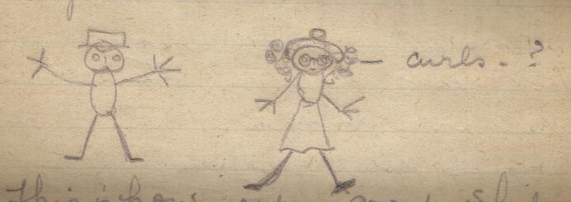

Figure 1.2

This is how our good ship was sailing on Thursday.

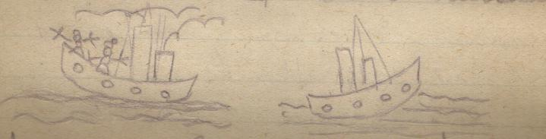

Figure 1.3

I a make a good Judy don’t I. I wonder if they could make a “pathe” picture out of this??????????
The YMCA Captain, (who by the way is a very nice sporty gentlemen) — Hugh doesn’t mind me saying this — Oh! he’s nipping me Mother, has made up quite an interesting programme for the rest of the time we are on board, namely —
Tonight This afternoon — children’s sports (and for anyone else who feels “childish” enough) tonight a whist drive, and suitable prizes are to be awarded, which will proceed from a collection taken last night.
Sunday — church service
Monday — afternoon, a boxing contest — No doubt our Hugh will receive a medel [sic] or two — It’s more than likely too??
Evening — a “sing song”
Tuesday afternoon — grown up sports.
Evening — (when going up the St. Lawrence River) a final concert, by special talent.
Wednesday morning — a baby’s show — I am going to show my baby off. I’m sure j he will get first prize. That’s my “wee Hughie Hugg”. He has been awfully good during the trip and has given me no trouble whatever. ha — ha (Hugh)

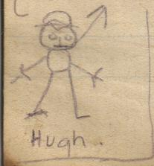

Figure 1.4

More people have managed to get up on deck this morning, and we had some difficulty in getting a good position on the deck.
Yesterday a small boat passed us, and last night, another passed about a mile away and showing all lights. —
Hugh has been paid a pound since coming on the boat, that is supposed to be for boat expenses, — and got a slip of paper, which he can get $5 for, when landing in port.
A sergeant whom Hugh knows, has just told me he does not know where I am going to find my letter box to post this. — I guess we shall have to send it by “registered parcel post”, so don’t think you are getting a present from Canada when an the postman hands it in.
Hugh thinks I should make a duplicate of this to show when we get to Storthoaks, to give them an idea of our trip across — But, I don’t think that is necessary, as we can do a bit of “spouting” to them.
You know Dad, it is your theory that I shall be a regular “washerwoman gossiper” so to uphold your kind remark I must have something to gossip about.
I must thank you on behalf of “my worser half” (here! — from Hugh) and yours humbly, for the cigarettes and choc.[olate] you gave us before sailing, we are eating some of the choc.[olate] now.
There is a canteen on the lower deck, where we can get what we want, and although our wants have been few, we have had a few delicious apples.
Picture me in my bunk eating apples, I eat one the last thing at night, and before getting up in the morning — “Eat an apple a day keep the doctor away. ” ?
This is a sketch of one side of a berth.

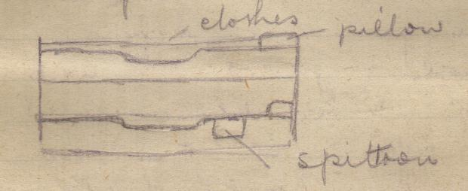

Figure 1.5

Those sleeping in a top bunk have a nice bit of climbing to do. I have found out that my bunk was a bottom one instead of the top, and I am not sorry for it is much nicer, and nearer the floor, for getting in and out of.
Oh! by the way you might tell “Uncle John” that he is missing golden opportunities by not crossing the “briny” for he could get lots of tips from a couple who do nothing but “suck each other’s gums” all day long. But even he might get disgusted at the sight. It is now nearly seven o’clock, & Hugh & I are sitting at the bac aft of the ship, where we are somewhat sheltered from the wind.
Here we shall be able to gaze on the watery expanse in the pale moonlight. — We shall have to imagine we see the moon though.
We have done a little over half the sea journey now. Well Goodnight a lot of kisses from your two “wee bairns”.

Sunday 9:35 [September 21, 1919]
Well this is Sunday, and out here on the mighty ocean, it seems hard to realise it, for everyday seems a like.
I was up at the usual time this morning, just a little before 6:30 am and met Hugh on deck. We had a good breakfast consisting of very thinly cut bacon, and egg. It must take some catering to provide such meals to every body on board.

The cooking & waiting is entirely done by men, and on our table we are well looked after.
I j guess you dear people will be about having dinner or perhaps got it over. You see we have to retard our time so much every night, last night it was fifty minutes.
We are making fine headway, and it is said we should pass through the “Bellisle straits” [sic] sometime tomorrow evening. I suppose the sail up the St. Lawrence river is most enchanting and we should enjoy some beautiful weather.
This morning is cold and misty, and seems to penetrate to the skin. However, I am nicely wrapped up, and you can hardly see my face for scarf.
Since breakfast we have been sitting here on the deck, wrapped up in blankets, reading, and as I have just finished my book I thought I would write a little more to this.
Did I mention that we have become acquainted with a Toronto lady. [?] She lives in a very swell part, and knows several people whom Hugh knows. I discovered yesterday that her name is McClatchey, and her husband is a Belfast man. She has been over in Ireland spending a four months holiday with her parents-in-law.
We have had some fine chats together, & she has given me her address, to look her up, should we care to call.
One of my berth companions is a Dublin girl, — her maiden name was Connelley. I asked her if she knew Portadown, & she said she had a cousin, or some relation there.
One of Hugh’s old boxing captains has been chatting to us for quite awhile, he has just left us. He was previous to the war, in some chief land offices, at Regina, & then finally at Moose Jaw. I asked him if he knew Uncle Stewart , & he says the name is familiar, although it is some years since he left there.
Tomorrow evening, if the atmosphere is at all clear, we should see our first sight of land, — Newfoundland.
I don’t think anybody will be sorry, for one needs a change of scenery after so long on the water.
I have enjoyed my ocean trip fine, up to now, and have a lovely healthy colour in my face, (and of course nose too.) Although I feel better than I have done for a long time.
Several people have complimented me on my good sailing abilities. — I suggested to Hugh, that we should buy a nice little yacht, and do a little cruising round the world occasionally — and I will be the “Mrs Captain” of the “floating palace.” —
I am afraid this letter will be somewhat untidy by the time it reaches you, for the paper is quite damp with the mist that is hanging around.
There is to be Divine service at 10:30 this morning, and another at 8:30 this evening. We are not attending this morning but hope to this evening, like good children.
I shall have to leave off again, as my fingers are numb with the damp clammy air. So goodbye until the next time — To be continued in our next. x x
Hello! Here I am again, it is just eleven o’clock and Hugh has just gone down to the canteen (or stores) to get me some apples. — There is beeftea, & boveril and tea etc., to be got there, which are nice warming tonics.
It is not dinner time for another three quarters of an hour yet, and you bet I shall be ready for it.
The “His majesty the Sun” is just peeping out now, so perhaps the mist will clear up before long.
Every time I think of something, I have to get out my pad and jot it down, in case I should forget it, when I want to write.
We have seen no whales yet, or any kind of fish. I should love to see a nice big whale.
Last night we had a fine view of the Northern lights, in the sky. The colouring was beautiful. You know, it is supposed to be a kind of triple mirror, shedding its light on the icebergs, that is the moon, & other forms. This is not a very clear definition but perhaps Oliver may be able to explain it to you in a much better way than I can.
6:15 pm
If only you could see my face, Cissie, it is as red as a rosy apple. Hugh says he has never seen me with so much colour. We are living a proper gipsy [sic] life of it, and are never in doors, except for meals, and at sleeping time. So I should look like a “blooming English Rose” when I arrive at Storthoaks. Hugh too has a face like a beet, so you can just imagine what a “guy” he looks. — I had better stop or I shall be getting into trouble —?
I think we must be getting nearer to the coast of Newfoundland, for the weather is terribly damp and misty. — Hugh thinks however that it gets warmer as we get nearer to “God’s Land.” (this is my land.)

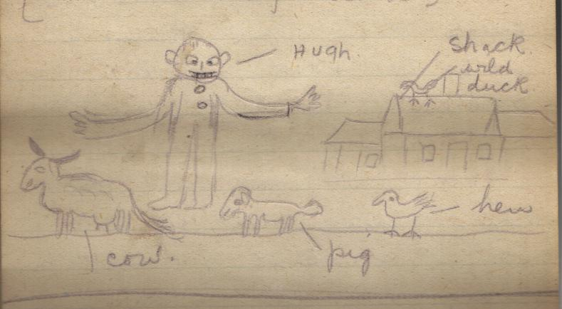

Figure 1.6
This sketch is drawn under Hugh’s tuition, of course not knowing what a farm cattle etc. look like, I have made a few mistakes, however I have labeled them so that you won’t get astray. ha — ha Goodnight x x

Bunk 7:55
Don’t you think I am a good little girl being in bed so early Mother dearest? Well it’s like this — The weather is just a wee bit too damp, and misty for us to be sitting up on deck, or even to stroll about, so as we both felt tired & ready for bed, we decided to go.
I have had to move my watch hands back 40 minutes tonight, which makes it seem rather earlier.
I am the only one in my berth at present and did not want to lie down to sleep just yet a while. — thus this thusness —
Has John got home yet —? Do you know it seems ages since I left home, and I keep wondering how you are going on, & what you are doing.
I am enjoying the sail fine, but shall be glad when we get to Quebec, & finally Toronto, for it is very monotonous gazing on nothing but water.
Of course there are other interesting sights namely — watching the various people passing by, — noting the different style in dress (and believe me there are some very peculiar ones).
Then again I love to listen to the many different dialects. — There are people from all parts of England, Ireland & Scotland. —
The number of soldiers on board is about 250, and the rest not including the dependents are civilians.
The captain whom I mentioned previously, says there are roughly 1400 men yet to be brought to Canada, 1000 of whom are Absent without leave, & cannot be traced.
One of the stewards is busy giving us some music on some kind of mandolin, out in the corridor. He plays very nicely, and it a[t] least helps to cheer up everybody.
Well, I think I will “lay me doon & sleep” for my eyes are very heavy. — The sea air is a splendid tonic, and to anyone suffering from sleeplessness should be a good sleeping draught. Goodnight all, God bless you. x x
Monday [September 22, 1919]
Quite a lot has happened today, and in fact it has been a very eventful one.
The morning was passed in the usual way, — had breakfast at seven o’clock, then we proceeded on to the upper deck, with our rugs, and found a comfortable seat. Here we sat until 11:45 dinner time, and passed the time, in reading, eating chocolate, and fruit etc. (sounds “snice” doesn’t it?)
At 2:30 pm there was a boxing contest. — The first two were a fairly good boxers, but the sailor got a his nose bled, and banged at his opponent, after he sat down, that he was disqualified. — Then came my wee Hugh, & his sailor — Of course Hugh put in a splendid fight exhibition & won the day. His opponent was the best boxer on board the Melita, among the crew. Following that we had a few bouts among youngsters, who caused some great amusement.
There were a host of other fellows who had put their names down on the boxing list, but they did not show up in the ring — probably they saw enough of the happenings before that, and took fright.
After that we had a sad, burial at sea. A blind officer on board, lost his three month old, baby, it died the day before.
The minister on board conducted the burial, and many hearts were touched. — The Mother & Father were there, and were greatly upset. It was all the more sad, seeing the man was blind.
At 4:30 we had tea, and until seven o’clock passed in the time in great excitement. Word spread along the deck that there were icebergs to been seen, this was as were [we’re] passing though between Labrador, & Newfoundland, before we struck the Bell Isle Straits [sic].
In the distance, we saw a huge iceberg, it looked like some great building, with a tower to it. — We passed not very far from it. A gentleman standing near, gave us his “eye glasses” (or rather “spy glasses”) to look through.
You have no idea what a grand thing it looked, I was surprised, for I had no idea they were so fine. We passed two others, shortly after.
During this time the ship was making excellent speed, so that we should pass through before dark. — It was reported that seven icebergs were seen, this was word sent by wireless.
Our next item on the programe of the days happenings, was, to get my “landing card” —This was at seven o’clock, or just a little after. Then came the “thing” Hugh was presented with a £1 for his boxing, the Captain’s words were “I now have to congratulate our old friend Clark, on his excellent exhibition” loud cheers, & much clapping — and my wee sonny walked bravely up, like a “blushing bride”? and received his £1 which he said he was going to spend on souvenirs for me. These were the conditions on which I let him box.
In the afternoon Hugh bought me a souvenir spoon of the ship, & also a large picture of the Melita, which we shall frame, when we get home.
Captain Rawson the Canadian Y.M.C.A. officer, gave us a very interesting lecture on “Bolshevism” — He has spent 18 months in Russia, and knows the true state of affairs, & the innermost workings of the country. It was a splendid lecture, & he was greatly applauded. I suppose that previous to joining the army he had been a parson. — His flow of speech, and eloquence, was astounding and he had no notes whatever.
After this we got up on to the deck, and lo! and behold, there were lighthouse lights glimmering in the distance. — Oh! my, but weren’t people joyful. — Just imagine, what a sight it is to see something different to sea! sea! sea! The lights were on the “Bell Isle Straits” [sic], so just at that time we were close to land on both sides which, had it been daylight, we should have been able to see.
Then came the close of a perfect day, bed and we said goodnight and came to bed, where I am at present, writing my epistle. Goodnight, sleep tight. x x

Tuesday 8:55 am [September 23, 1919]
Good morning dearest parents — It’s a most glorious day, — for Ducks? and no land in sight, for we are in the Gulf of the St. Lawrence. However, we are supposed to see land about noon if the weather clears up.
3:15 pm
Have just been examined by doctor, for vaccination — I have passed alright [sic], so that is something more done.
We are supposed to dock in Quebec tomorrow evening sometime, but we do not leave the boat until Thursday sometime.
Today we have spent most of the time indoors, as the weather has not been too fine.
I am in my berth at present, waiting for Hugh, who is queuing it, to get his pay book. How long he will be, I don’t know, for they are standing in District position, & Saskatchewan comes pretty near the last.
Here he comes, with his pay book, & everything is quite o.k.

7:40 pm

Land! Mother, land! We are now passing the Anticoste Island, which is a tremendous length, but only very narrow.
It is now quite dark outside, and we see glimmers of light, flashing out from the lighthouses.
This Island, so an officer of the crew, was telling us tonight is owned by a very eccentric French Millionaire who just uses it as a hunting ground, for game.
We have seen several other boats, one a coalier (?) which we soon passed, and left behind.
It is awfully cold on deck, but oh! the glorious sunset, and red sky. I have never seen anything like it, in England.
Hugh has just been figuring up his pay, and it amounts to £33 (about) which he gets on arriving at Quebec. After that he gets his gratuity, but he does not know yet, how much it will be.
At the present time, we are sitting in the Dining Hall, waiting for a concert that is going to commence at eight o’clock.
Everybody is in great excitement tonight, at seeing land, and huge crowds gathered on various parts of the decks to look on the great and wonderful sight, land!
Before coming in here, Hugh took me the whole length of the boat, “way down among the fishes”, to see the engines that work the Melita.
The engine room is an enormous size, and one huge mass of machinery etc.
There is a great babble going on in this Hall at present, every body is telling the tale at once, & trying to see who can make the most noise, it sounds great, you can guess.
Some are playing cards, while others are crocheting, nursing babies, and the rest who don’t feel inclined to talk, are just gazing on the scene, with eyes, & ears open.

Wednesday 8:20 am [September 24, 1919]
Here we are again — It is a glorious morning, & the sun is shining brightly. The clouds are disappearing, and we look like having a beautiful blue sky.
We are now a good way up the St. Lawrence River, and have land on both sides of the river, on one side we have a fine view of the Hills, and smuggling at the base are fishermen’s huts, which of course look like little white specks in the distance.
The water is as smooth as a Mill pond, and everything is glorious.
We are not travelling at a very great speed just now, as they have to be careful of sand hills, which form under the water.
Hugh & I are sitting at the rear of the boat, and are getting the full benefit of the warm morning sun.
We dock tonight, but do not leave the boat until tomorrow morning, so we have one more night on the boat yet.
There is another boat coming along, which I believe is a freighter, & on the other side a big fishing sailing schooner.
About half an hour ago, we passed a little fishing smack, and it did look nice, with its white sails all set.
Last night we had a fine concert — One young lady sang “Angus Macdonald” — A man awfully like Jack Luke, played us two scotch selections on the violin, which caused much “hooching” among the scotch folks there — I just thought what a good “Hooch” Jack would send forth —?
Oh! Oliver I should not advise you to get a transparent rain coat, but one like Fred’s, as there are several being worn on this boat, & they don’t last any length of time, and look awful. Don’t get it Rubber —
By the time this letter reaches you, I hope you will have received the P.C. [postcard] we posted on board. It should reach you in about ten days time. I cannot post this until we reach Quebec, as I have no large envelopes to put it in.
Have just had my first sight of the Maple leaf, a way on the Hills, just tinged with red.
There’s a large “porpus” (?) in the water not far from the boat. At first we thought it was some shooting spray, but discovered it was a fish.
The scenery is beautiful now, & we are much nearer to the land on one side — and can discern churches, & houses etc. All the country is densely populated with trees. —
We can see a train now — Hugh pretty nearly jumped overboard in his glee — ha — ha.
This is the best part of the journey. — There is no wind at all, & everything is so calm, while “his majesty the sun” is shining “to beat the band.” —You see I am Canadian already, now we are at “God’s Land”?
We have seen some wild ducks too, going at great speed along the surface of the water, all flying in a line.
The old sailor is getting ready to hoist the flags, now that we are getting nearer — to civilization.
On the banks are small farms, owned by French Canadians. They live in houses in a row, and have just a one horse farm, part which are very long and narrow. They just make enough money to enable them to get jin [gin] & a own a fiddle — and enable them to go to church. One of the crew officers told us last night, that it was nothing but churches & pubs, along the bank of the St. Lawrence.
I had the opportunity of looking at a church through some glasses, — it…

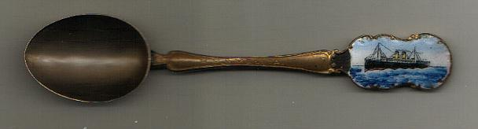

Figure 1.7 – This is the spoon Grace purchased with the money Hugh won in the boxing match.

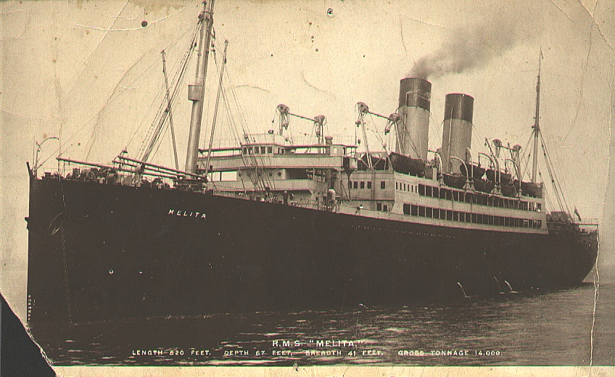

Figure 1.8 – This is the large postcard print of the Melita that Grace purchased with the money.

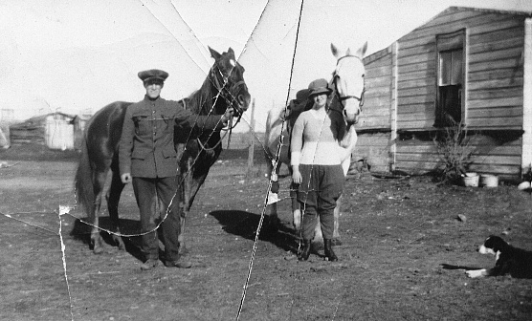

Figure 1.9 – Hugh and Grace in Storthoaks, circa early 1920s.

Grace Clark’s letter was written in September 1919 while on board the SS Melita. Permission to use this transcription must be obtained from the current owner of the letter:

Annette Fulford
12482-231A Street
Maple Ridge,
BC Canada
V2X 0G1
604-463-7119
Email: arfulford@shaw.ca

The ship left Liverpool docks the day before on 17 September 1919. [Source: Library and Archives Canada, Quebec Passenger Lists: SS Melita, Microfilm T-14702, 17-25 September 1919]
Cissie is Grace’s younger sister, Sarah, born 1901 in Belfast, Northern Ireland. She was also known as Sissy or Sallie.
I believe she means a Boudoir cap, a lace cap meant to cover unkept or undressed hair.
Does she mean Judy of the famous English puppet play Punch and Judy?
Uncle Stewart is Stewart Gibson (1866-1934), her father’s eldest brother.
Oliver is Grace’s younger brother born in 1903 at Belfast, Northern Ireland.
This is Grace’s younger brother John Robert Gibson born 1899 at Belfast, Northern Ireland. Update 2005: I recently found a photo of him taken during World War One with a military uniform on indicating he joined the service for his Country.
The baby’s name was John D.Hitchon. His parent’s were Lieutenant Wilton Wallace Hitchon and his wife, Edna, of Brantford, Ontario. [Source: Library and Archives Canada, Quebec Passenger Lists: SS Melita, Microfilm T-14702, 17-25 September 1919]
The spoon and the original letter are now in the possession of Annette (Clark) Fulford, who is a granddaughter of Hugh and Grace (Gibson) Clark. The whereabouts of the picture of the ship Melita is unknown. Update 22 January 2005: I found the picture of the ship in a box of old family photos given to me by my brother. It has some damage but is still in good condition.

